**How to run Ncmaz theme**

**- download and learn nvm(node version manager) from here:**

**https://www.youtube.com/watch?v=tFxPR6-BYOs**

**- now open command prompt as "Run as Administrator"**

**- now type "nvm" press enter then type "nvm install 12.13.0" press enter**

**(you have to install node version 12.13.0 to run Ncmaz theme"**

**- now type "nvm use 12.13.0" to use this version of node.**

**- now close the command prompt.**

**- now go to the theme directory**

**(themeforest-VD6dfRuc-ncmaz-blog-magazine-react-template -> Ncmaz)**

**go to the Ncmaz folder and open command prompt**

**- now type "npm install" in the command prompt and press Enter then wait for the installation to complete.**

**- now type "npm install -D" in the command prompt and press enter after the installation.**

**-now after the installation of all dependencies close the command prompt and go to the Ncmaz folder then**  
Open **src -> routers -> index.tsx** and remove (or change it to yourself) **basename** in <BrowserRouter>

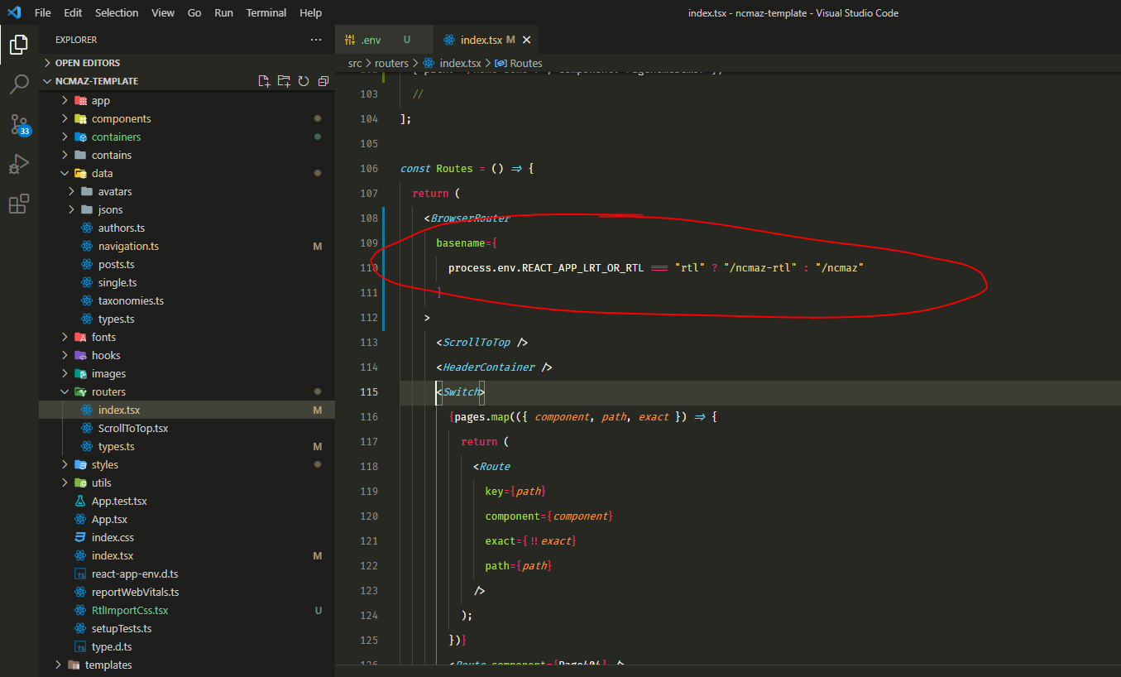

-now Open **package.json** change homepage field to "homepage": "."

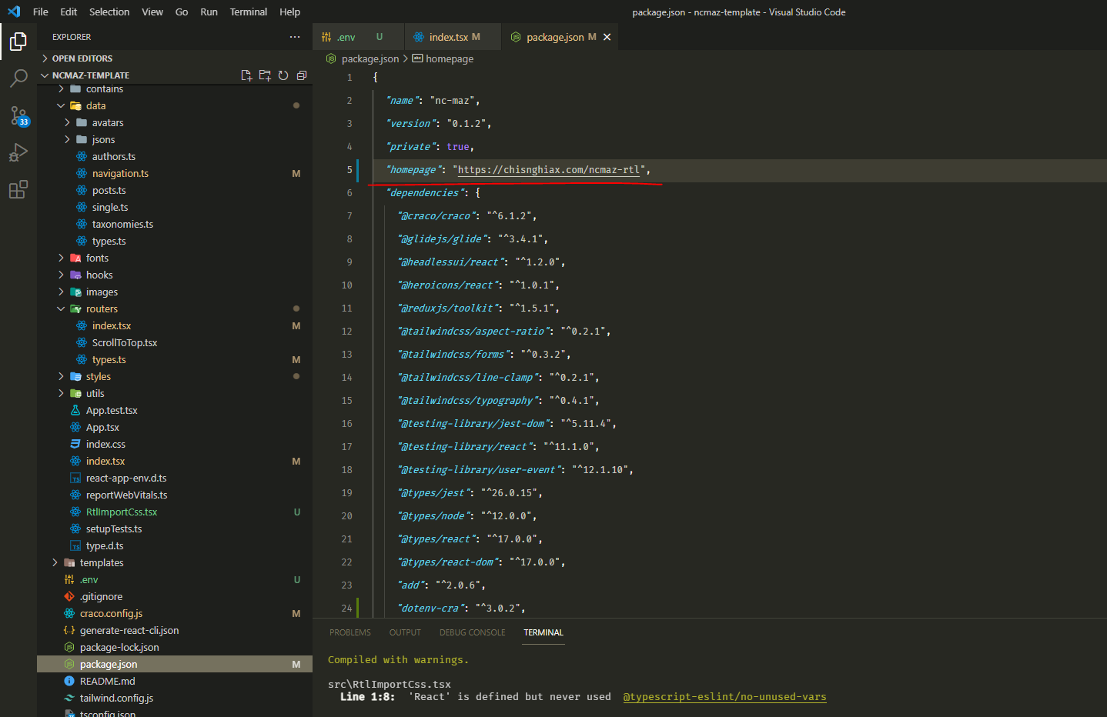

**-Now run the project with “npm start”**